FTT Manual

The stand-alone MATLAB version

**Table of Contents**

MATLAB 2

Step 1: Downloading Matlab 2

Step 2: Create a license file 2

Step 3: Receive installation key from PV 2

Working with FTT:Power 4

Step 1: Download the FTT model(s) from the Google Drive directory 4

Step 2: Start MATLAB and select correct working directory 4

Step 3: Scenario setting 5

Contents of FTT:Power 5

Step 4: Scenario running 7

Step 5: Plot graphs 8

Step 6: Extracting the numeric data 8

# MATLAB

## Step 1: Downloading Matlab

You can download Matlab version R2015a from the Google Drive folder:

<https://drive.google.com/open?id=1cdIDWxG_A32QRi01QO9I3AUILRFrjZ-x>

This version works for either Macosx or Windows.  
N.B.1: 7zip has no problems with this large file, some Windows Zip programs do.  
N.B.2: Old versions of Internet Explorer have problems downloading files larger than 4GB, so will fail.

## Step 2: Create a license file

Make a notepad file with the following two lines and save it as “license.lic”:

SERVER matlab.science.ru.nl 782BCB673EA6 26000  
USE_SERVER

(make sure these are the only two lines in this file)

Add this file to the MATLAB folder.

## Step 3: Receive installation key from PV

Preferably, bring your laptop to the next session if you want to start working with FTT.

!Only install MATLAB!



Sometimes you are prompted to insert the full path name of the “license.lic” file. In that case you do the following:

* Select the license.lic file in the directory of MATLAB.
* Click on “Copy full path” as shown below

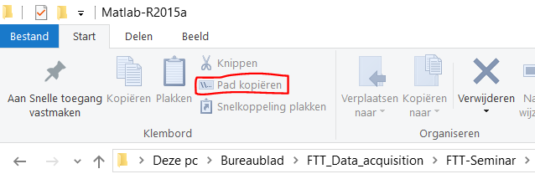

* You can now paste the path in the field and proceed to install MATLAB.
* After this you should have a working version of MATLAB.

# Working with FTT:Power

## Step 1: Download the FTT model(s) from the Google Drive directory

You will have access to the FTT:Power, FTT: Transport, FTT:Heat and a preliminary FTT:Steel model. Unpack the files in a directory of your choosing.

Google Drive link:

<https://drive.google.com/open?id=1cdIDWxG_A32QRi01QO9I3AUILRFrjZ-x>

## Step 2: Start MATLAB and select correct working directory

Start MATLAB. In the top, you can select the working directory. Please select the directory where you saved the FTT model.

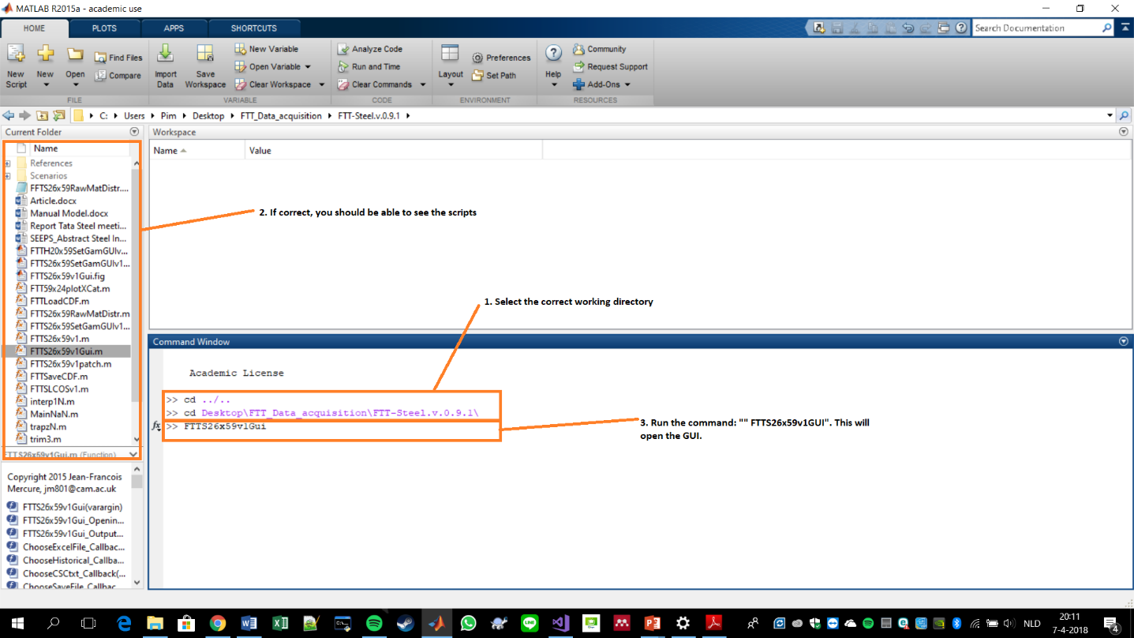

Go to the command line window. At the >>, type in the name of the model graphical user interface (GUI), which is FTT53x24v7Gui

>> FTT53x24v7Gui



In the ‘Files’ box of the interface, you will see an input field called ‘Assumptions’. This file is an excel spreadsheet in which you will be writing policy assumptions. The interface needs to know where this file is. Click the ‘...’ buttin to the right of this field. Locate the file called “FTT53x24v7_Policy_Base-Students.xlsx”, which is in a subfolder called “\Scenarios\”.

## Step 3: Scenario setting

For this stand-alone version, the scenario setting is done within the excel files. In each of the FTT models the scenarios have been numbered. No. 0 is usually the baseline scenario. All sheets ending with this number should not be altered, unless there are real-world policies in play (e.g. Carbon Tax). Other excel sheets can be adjusted at will.

## Contents of FTT:Power

**List of variables:**

S – Shares of capacity $S_{i}=\frac{U_{i}}{\sum{U_{i}}}$

G – Electricity generation in GWh/y

U – Electricity generation capacity in GW (power plants)

E – CO2 emissions (Gt)

CF – Capacity factors (% of full time generators are operating)

LCOE – Levelised cost of electricity (2008$/MWh), including carbon price but no other policies

TLCOE – LCOE as seen by investors, with all policies, used in the choice model

LCOEs – LCOE without any policies, only technology and resource effects

W – Cumulative capacity production for learning curves (GW)

I – New built generation capacity, (GW/y)

P – Marginal costs of producing fuels, per fuel type.

TPED – Total primary energy demand by fuel type.

T – Taxes or subsidies (fraction between 0 and 1)

FCosts – Fuel costs (2008$/MWh)

ICosts – Investment costs in the LCOE (2008$/kW)

CFCosts – Inverse of the capacity factor as appears in the LCOE

CO2Costs – Carbon costs (2008$/MWh)

S_lim – Share limits 1 (see Fig 2 in Mercure 2012)

S_lim2 – Share limits 2 (see Fig 2 in Mercure 2012)

**Policy levers**

FTT:Power is a model with one of the most detailed list of policy options of all global electricity models available. Evaluating policy impacts, and, especially, the impacts of combinations of policies is what FTT is designed for. FTT currently has 5 types of policies that can be applied independently in all regions, specified in corresponding excel sheets

1. **Subsidies** (Sub): Subsidies on the capital cost of technologies (e.g. public-private partnerships). This is specified as a negative % of the capital cost by region and technology in the ‘SubX’ spreadsheet (X is the scenario number)
2. **Feed-in tariffs** (FiT): Feed-in tariffs are prices offered to producers for their electricity below market price. They are specified in $/MWh subtracted from the bare LCOE (the producer receives this additional amount of money, which makes his costs this much less). Take care that FiTs can lead to negative LCOEs, which is highly unrealistic.
3. **Regulations** (Reg): Capacity cap in GW. Determines what can be built or not. If the current capacity in a country/technology is higher than the regulation value, no more units can be built and existing units are replaced at the end of their lifetime by other technologies. Capacities below the cap cannot grow to values above the cap. Specified in the RegX sheet.
4. **Carbon price/tax** (CO2P): Tax applied to emissions by electricity generators proportional to their emissions, in $/tCO2. This is specified in sheet CO2PX, either in Euro/tC (top matrix) or 2008 US$/tCO2 (lower matrix). The software reads the matrix below, but a conversion can be used. One value per country and year can be specified.
5. **Exogenous capacities** (MWKA): Command and control government planning on electricity generation capacity. This is specified in sheet MWKAX, in which capacities are specified in GW per technology/country.
6. **Demand management and electricity storage** (DP): These are not quite policy instruments, but exogenous parameters, which can be related to policy. There are 4 of these:
   1. Electricity peak capacity demand to average capacity demand ratio (% = GWpeak/GWavg)
   2. Electricity peak demand to average demand ratio (% = GWh_peak/GWh_avg)
   3. Electricity storage generation capacity to total generation capacity (% = GWst/GWtot)
   4. Electricity storage available to total electricity generation ratio (% = GWh_st/GWh_tot)

These parameters create flexibility for the diffusion of renewables or baseload technologies according to Fig2 of EP Mercure (2012).

## Step 4: Scenario running

Prior to running the scenario of your choosing, you should load history. This is a timesaving step to prevent us from loading the historical values of several parameters for every scenario calculation (**see 1** in figure below). Then select the correct scenario you wish to calculate (**see 2** in the figure below). Below the ‘Files’ box you have a box called ‘Calculate Scenarios’. Click the button called ‘Calculate Scenario’ (**see 3** in the figure below). This will read the excel spreadsheet and calculate the scenario of your choosing. Afterwards you can choose to save the result of your scenarios, that way you don’t have to calculate the scenarios every time (**see 4** in the figure below).

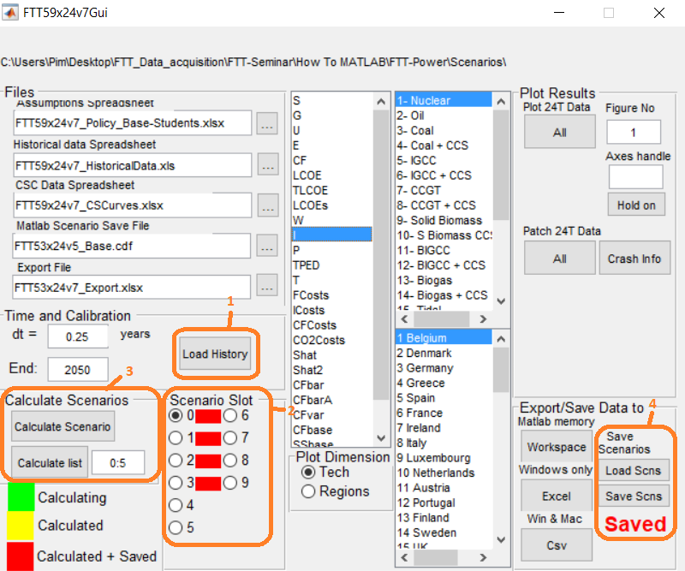

## Step 5: Plot graphs

First, choose the variable you want to plot from the list of variables (**see 1** in the figure below). Secondly, you choose the technologies or fuel types from the upper box to the right of the variables list (**see 2** in the figure below). It depends on the variable whether it will show power generation technologies or fuel types. E.g. the market share variable ‘S’ will show the different technologies, while the total primary energy demand variable ‘TPED’ will show you the different fuel types. Then you can select the regions (**see 3** in the figure below). It is possible to view the results over two different dimensions, either the technological specific dimension or the region specific dimension (**see 4** in the figure below).

The Graphical User Interface has two distinct options of plotting the data. Either it plots all variables as a line plot or it plots all variables as a stacked area plot (**see 5** in the figure below). To the right you have a box called ‘Plot Results’. This has buttons that enable you to make all sorts of graphs, for example electricity generation by technology for one country, or for one technology and all countries, etc. If you want to plot multiple figures side-by-side then you have to select a unused figure no. (1-99) and select the variable/technologies/regions as by your choosing (**see 6** in the figure below)

## Step 6: Extracting the numeric data

If you want to extract the results to excel or a CSV file then the Graphical User Interface offers you this option. **See 7** in the figure below. Please note: If you are using a Mac computer then you can only use the CSV option.

